EV Charge & Range Analysis Project

1. Project Overview
This project provides a visualization tool for analyzing electric vehicle (EV) charging behavior, range, price, and performance using interactive dashboards created in Tableau and displayed through a web interface.

2. Data Preprocessing Steps
- Loaded EV dataset from CSV file.
- Checked for missing and invalid values in key columns such as range, price, and battery capacity.
- Cleaned the 'Range' column by extracting numeric values from text entries.
- Converted textual numeric fields into integer or float data types.
- Removed or replaced records containing 'NA' or invalid values.
- Standardized units for range and price.
- Verified data consistency across columns.
- Created calculated fields such as average range and average price.
- Prepared cleaned dataset for Tableau dashboard creation.

3. Dashboard Description
The dashboard displays key performance indicators such as average range, average price, charging stations by region, and car model comparisons.
Dashboard screenshot to be inserted here before final submission.
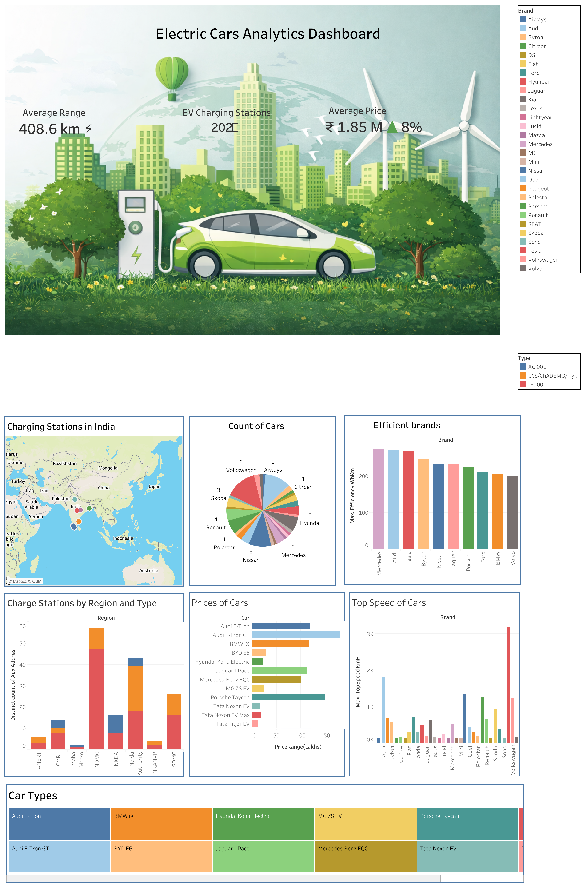

4. Story Description
The Tableau story explains insights such as price vs range, regional charging infrastructure, and comparison between different EV brands and models.
Story screenshot to be inserted here before final submission.
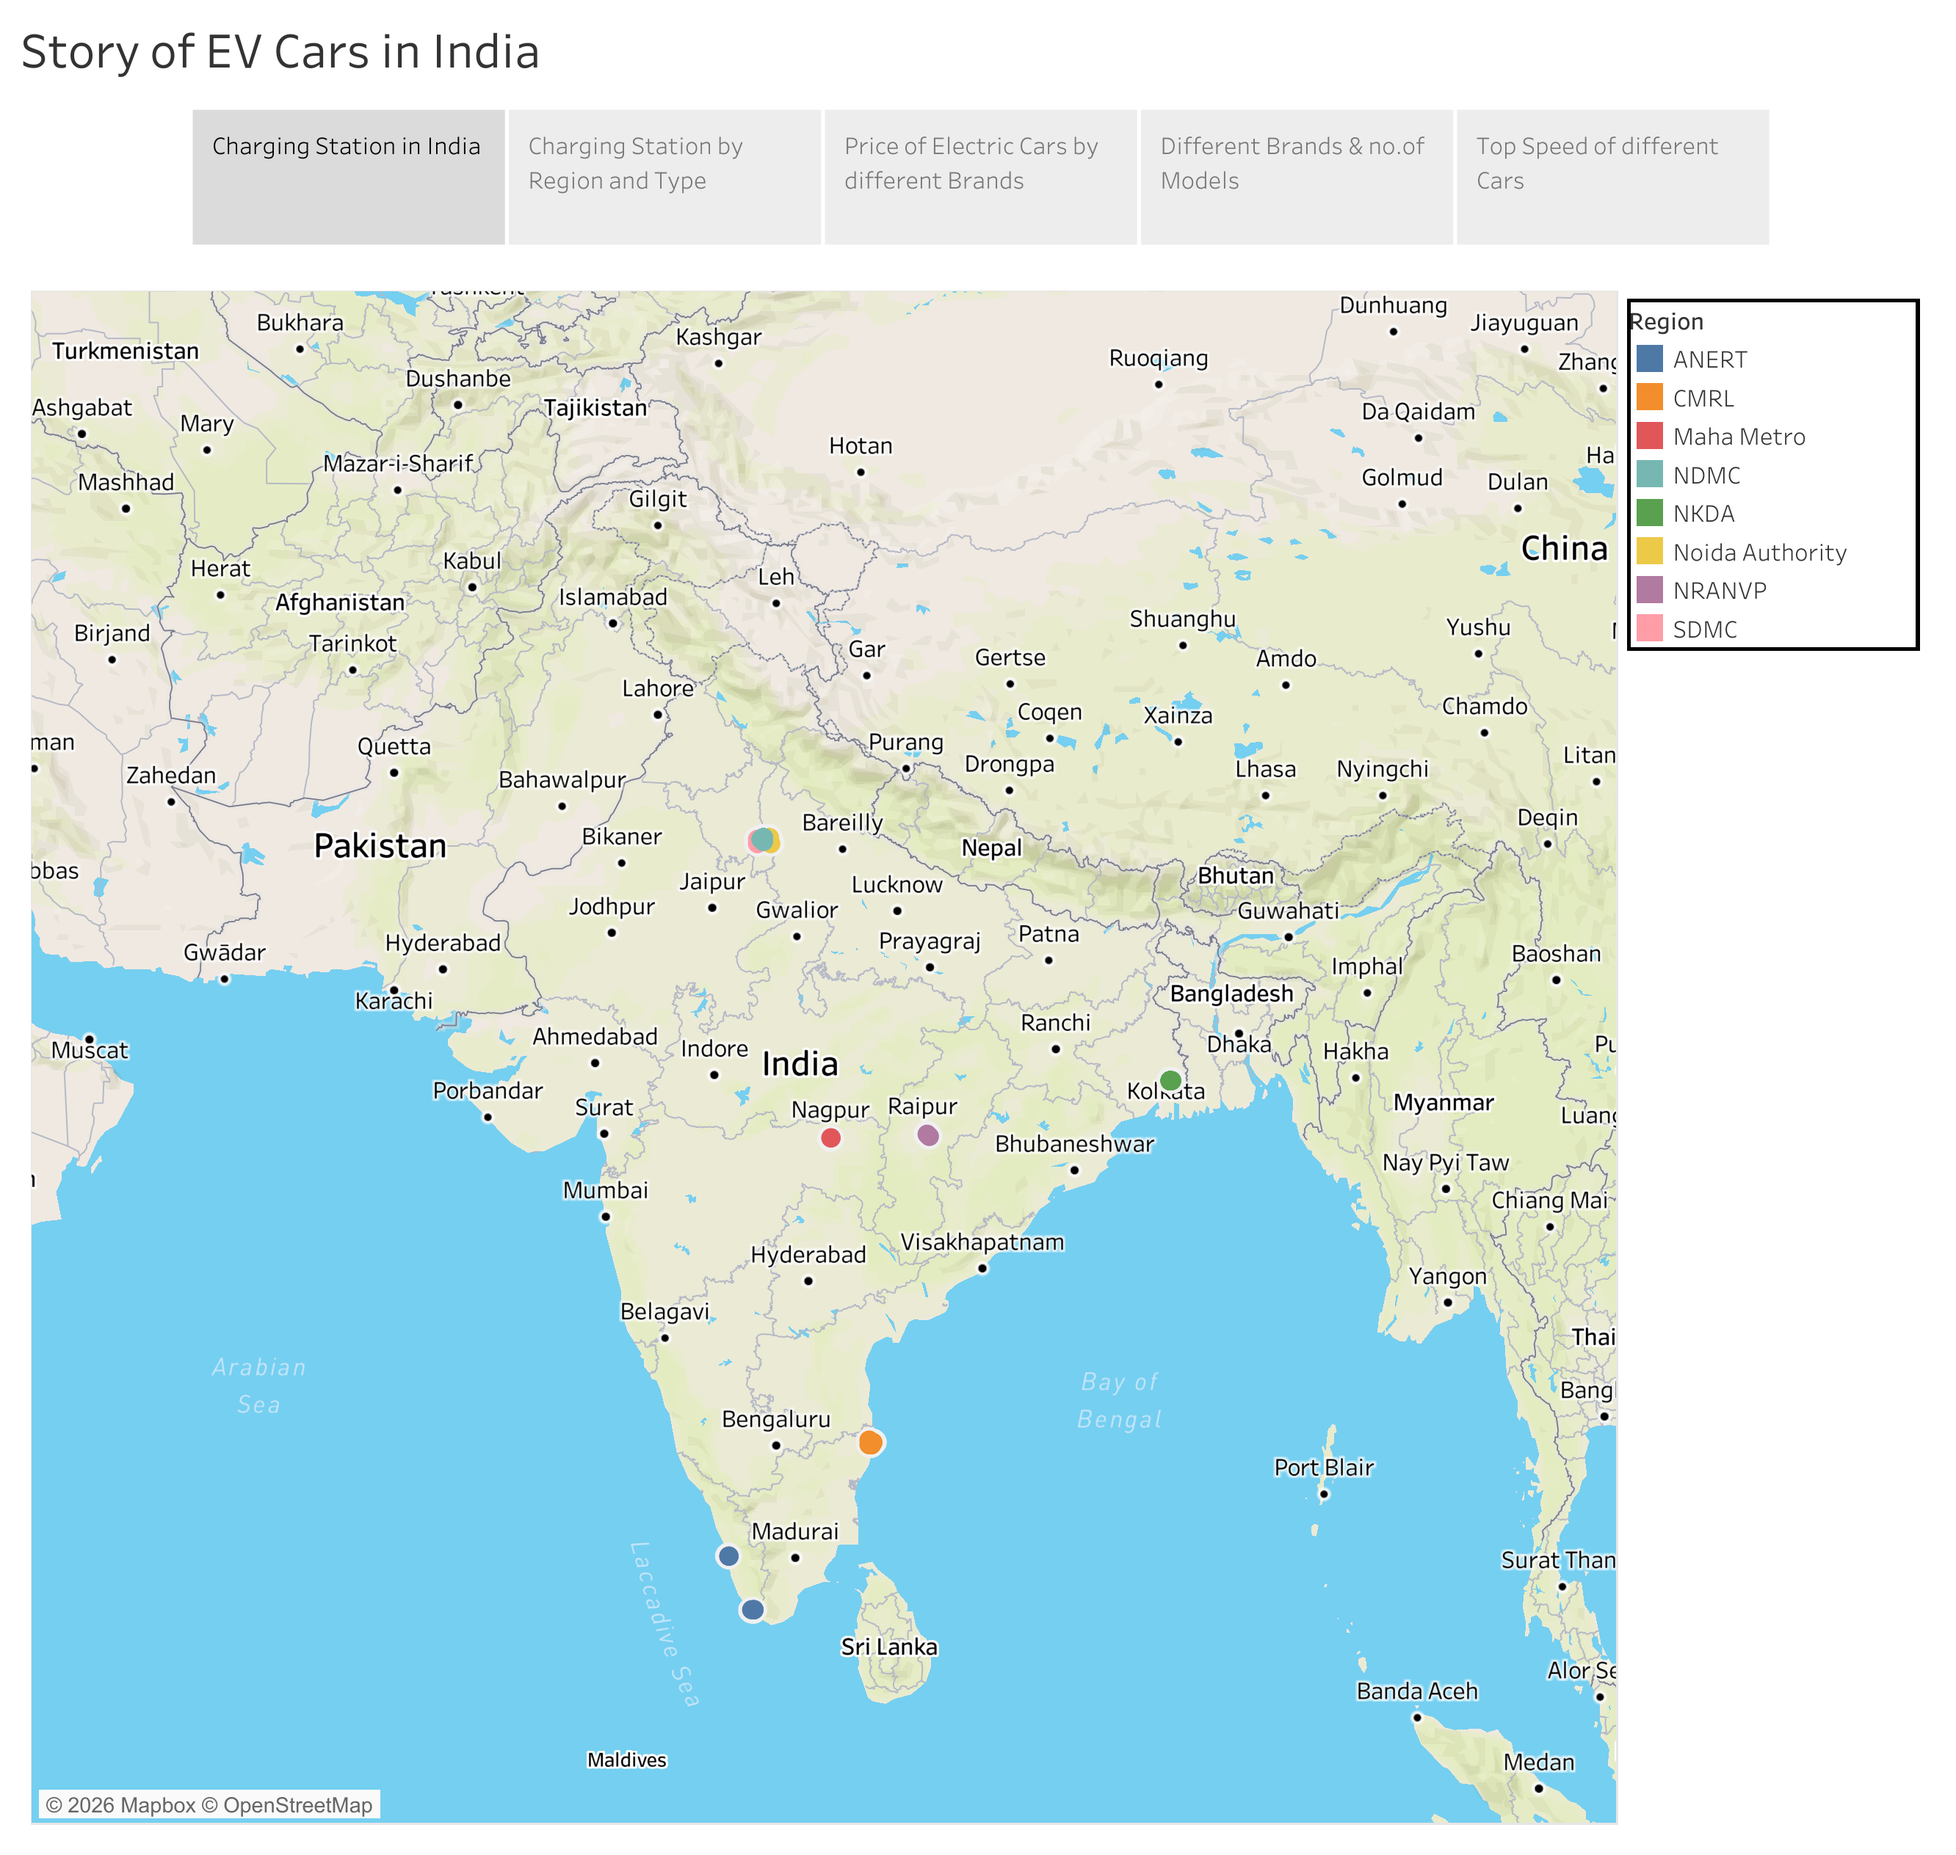

5. Conclusion
The EV Charge & Range Analysis tool helps users understand electric vehicle performance and charging infrastructure using interactive visual analytics.

